# NO2:

**AIM**: program to find largest of three numbers.

**Procedure:**

#!/bin/bash

read -p "Enter first number" a

read -p "Enter second number" b

read -p "Enter third number" c

if(($a > $b & $a > $c))

then

echo "a is the greatest"

elif(($b > $a & $b > $c))

then

echo "b is the greatest"

else

echo "c is the greatest"

fi

**output:**

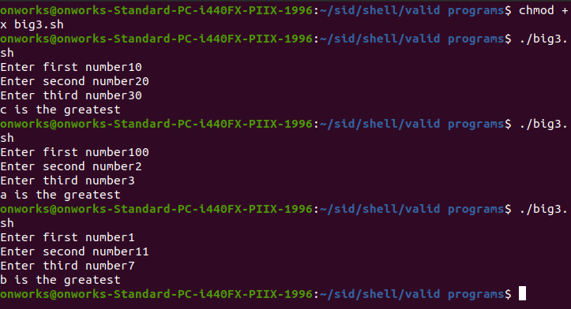

# Result

The program was executed and the result was successfully obtained. Thus CO3 was obtained